REGISTRATION OF INTEREST
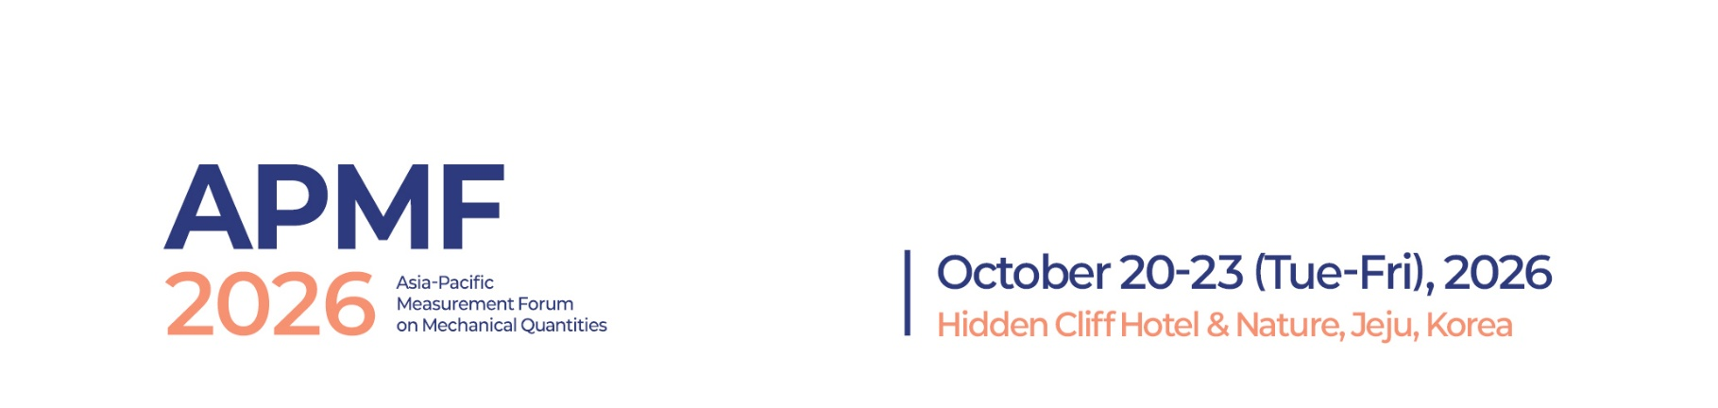
□ I intend to submit a paper with the following provisional title (abstract attached).
□ I do not wish to submit a paper but would like to attend the symposium.
□ I will be accompanied by my spouse or family.
- Number of accompanying persons: ( )
- Number of Accompanying all persons attending the banquet: ( )
* Additional banquet ticket: USD 100 per person.
□ I will participate in the Technical Tour.
PERSONAL DATA
Name : (Dr/Prof/Mr/Ms)
(Given Name) (Surname)
Position/Title :

Organization/Company :

POSTAL ADDRESS
Street :
City : Zip Code :
Country :
Phone : | (including country and area codes)
Email :

